



**Electronics and Communications Department**

**Graduation Project 2023/2024**

**First term report**

**Security Enhancement of Open Flow Networks**

**Prof. Ihab Abdel Wahab Ali**

**For the Month of February,20**

**Table of contents**

|  |  |  |
| --- | --- | --- |
|  |  |  |
| **Chapter 1** | **1 Introduction**   * 1. SDN   2. Difference between SDN and traditional networks | **Page.4** |
| **Chapter 2** | 2**.Software and applications used** UbuntuVirtualization software(hypervisor)  * 1. Mininet  2.4Pox Controller | **Page.9** |
| **Chapter 3** | **Implementation of network**First TopologySecond Topology3.2.1Problems of single Controller 3.2.2Implementation of second Topology | **Page.12** |
| **Chapter 4** | 1. **Server/Client Communication**    1. Overview    2. Implementation of the Server/Client Communication | **Page.21** |
| **Chapter5**  **Chapter 6** | 1. **Point to point Communication**    1. Netcat tool    2. Netcat installation    3. How to use netcat tool 2. **Web service**   6.Benifis  7.The implementation | **Page.32**  **Page**.**36** |
| **Chapter 7** | 1. **traceroute**     1. Installation of Trace route tool    2. Trace route tool usage | **Page.41** |
| **Chapter 8**  **Conclusion**  **References**  **Figures** | 1. **Route Validation in SDN Network**     1. How to validate routes by adding more links    2. Validate source and destination ends    3. Capturing data through Wireshark    4. Observations | **Page. 45**    **Page.49**  **Page.50**  **Page.51** |

**Chapter.1 Introduction to SDN**

In recent years, the Networking landscape has undergone a significant transformation with the emergence of Software-Defined Networking (SDN). SDN represents a paradigm shift in network architecture, offering a more flexible, scalable, and programmable approach to the network management and operation compared to traditional networking models. This introduction aims to provide an overview of SDN and highlight its key difference from traditional networks.

**1.1. SDN**

SDN is a revolutionary approach to networking that decouples the control plane from the data plane, enabling centralized control and programmability of network devices through software-based controllers. In an SDN architecture, the control plane, responsible for making decisions about how data packets should be forwarded, is abstracted, and implemented in software running on centralized controllers. This separation of control logic from underlying network hardware allows for dynamic, policy-driven management of network resources, simplifying network configuration and enabling automation and orchestration of network services.[1]

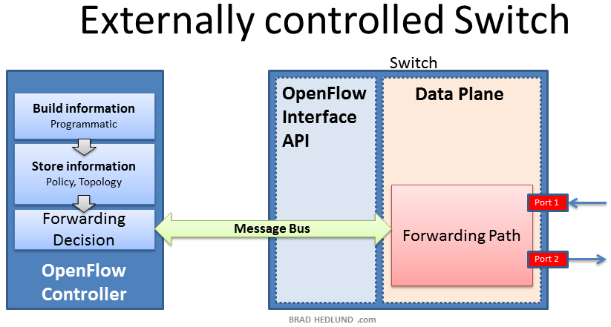

Fig.1.Externally controlled switch

The SDN architecture consists of three distinct layers that are accessible through open APIs:

• The Application Layer consists of the end-user business applications that consume the SDN communications services. The boundary between the Application Layer and the Control Layer is traversed by the northbound API.

• The Control Layer provides the logically centralized control functionality that supervises the network forwarding behavior through an open interface.

• The Infrastructure Layer consists of the network elements (NE) and devices that provide packet switching and forwarding.[1]

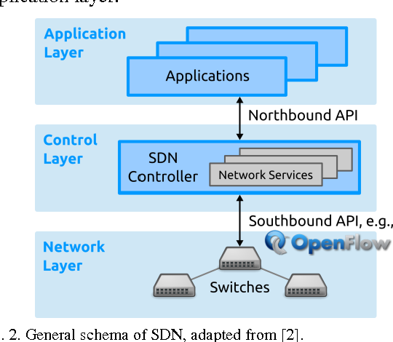

Fig. 2. General schema of SDN.

**Architectural Components of SDN:**

* Southbound API (Downward):
  + Connects SDN controller to network devices (switches, routers).
  + Controls data plane devices from the controller.
  + Examples: OpenFlow, OVSDB.[2]
* Northbound API (Upward):
  + Connects SDN controller to external applications or services.
  + Allows higher-layer control and communication.
  + Examples: RESTful APIs, Java APIs.[2]

**1.2. Differences from Traditional Network.**

While traditional networking architectures rely on distributed control mechanisms embedded within individual network devices (e.g., switches and routers), SDN introduces a centralized control plane that orchestrates the behavior of network elements. This fundamental shift brings several key differences between SDN and traditional networks:

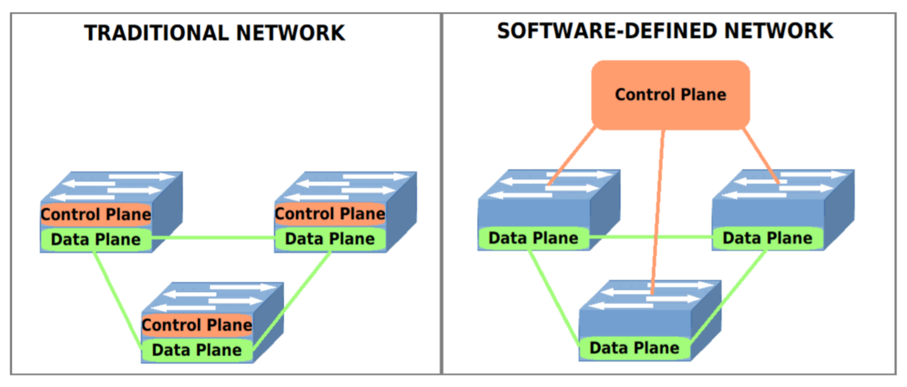Fig.3.SDN VS Traditional networks

**Centralized Control:** in traditional networks, control functions are distributed across network devices, leading to complex, decentralized management. In contrast, SDN centralizes control and management functions on software-based controllers, providing a unified view of the network and enabling consistent policy enforcement and optimization.

**Programmability and Flexibility**: SDN offers greater programmability and flexibility compared to traditional networks. With SDN, network administrators can dynamically configure and customize network behavior through software-defined policies, allowing for rapid adaptation to changing network requirements and application needs.

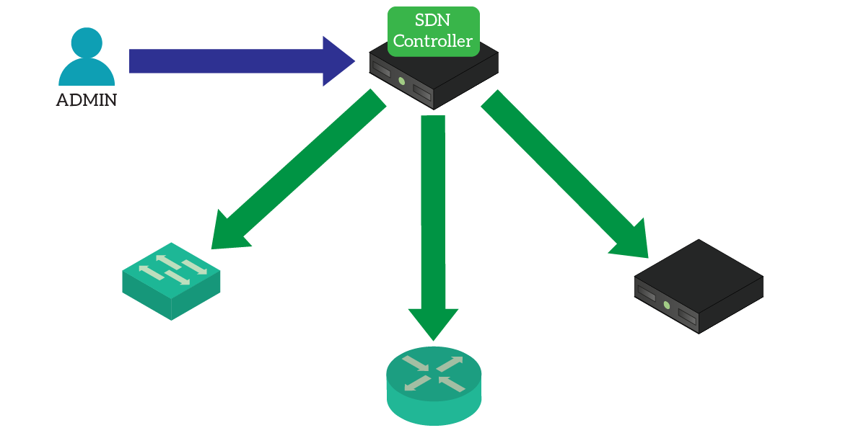

Fig.4.The SDN controller pushes the configuration to different devices.

**Automation and Orchestration:** SDN enables automation and orchestration of network resources, streamlining provisioning, configuration, and management tasks. By abstracting network control into software, SDN simplifies complex operations, reduces manual intervention, and accelerates service delivery.

SDN promotes openness and interoperability by standardizing interfaces between the control plane and network devices. This facilitates integration with third-party applications and services, fostering innovation and enabling the development of diverse network applications and services.

**Scalability and Agility**: SDN enhances network scalability and agility by decoupling control logic from underlying hardware. This allows for the dynamic scaling of network resources and the rapid deployment of new services and applications without requiring extensive changes to the underlying infrastructure.

**Chapter.2 Software and applications used**

**2.1. Ubuntu**

Ubuntu is a popular Linux distribution based on Debian. It is an open-source operating system that is known for its ease of use, community support, and regular release cycle.

Ubuntu is widely used by individuals, businesses, and organizations around the world. It is known for its stability, security, and performance, making it a popular choice for servers and other mission-critical systems.

**2.2. Virtualization software (hypervisor)**

Virtualization software is used to create and run virtual machines (VMs) on a physical host machine. These virtual machines can run different operating systems and applications, allowing for increased flexibility, efficiency, and resource utilization, we use VirtualBox.

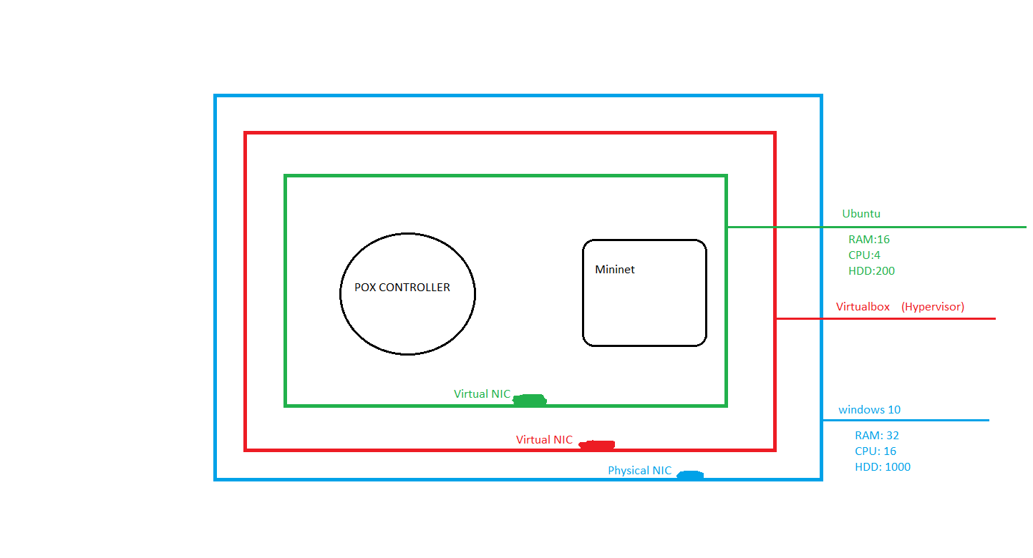

Components selected.

**2.3 Mininet**

Mininet is a network emulator that simulates a collection of end-hosts, switches, routers, and links on a single Linux kernel. Each of these elements is referred to as a “host.” It uses lightweight virtualization to make a single system look like a complete network, running the same kernel, system, and user code. Mininet is important to the open source SDN community as it is commonly used as a simulation, verification, testing tool, and resource. Mininet is an open-source project hosted on GitHub [3].

**2.4. Pox controller**

POX is the newer, Python-based version of NOX (or NOX in Python). The idea behind its development was to return NOX to its C++ roots20 and develop a separate Python based platform (Python 2.7). It has a high-level SDN API including a query-able top‐ ology graph and support for virtualization.



Fig.5. Pox controller

POX claims the following advantages over NOX:

• POX has a Pythonic OpenFlow interface.

• POX has reusable sample components for path selection, topology discovery, and so on.

• POX runs anywhere and can be bundled with install-free PyPy runtime for easy deployment.

• POX specifically targets Linux, Mac OS, and Windows.

• POX supports the same GUI and visualization tools as NOX.

• POX performs well compared to NOX applications written in Python.

NOX and POX currently communicate with OpenFlow v1.0 switches and include special support for OpenvSwitch[4].

**Chapter.3 The Implementation**

**3.1. First Topology**

- Starting with Ubuntu to install mininet by typing the following commands in the terminal: -

*$ sudo apt-get install git-core.*

*$ git clone git://githup.com/mininet/mininet*

*$ sudo apt-get update.*

*$ sudo apt-get install mininet*

*$ sudo mn*

* The **first** command used to install git core to clone repositories(resources) from there.
* The **second** command used to clone the mininet repository from the link.

Note: After cloning the githup repository of mininet it should be available in /home/.

* The **third** command is used to update the apt database to install the mininet and its dependencies.
* The **fourth** command used to install the mininet. Note: Now we can test by running the **fifth** command →it create the default topo.

- installation of controller (POX) by the following command: -

*$ mininet/util/install.sh -p*

After installing the POX, it should be in the directory /home/

Note: to test the POX controller type the next command:

*$ python2 pox.py forwarding.l2*

It should be up now.

-We now can create our topology for the project.

-As a start we create a tree topo that includes the following:

*(The pox controller – 9 OpenFlow switches – 64 pc device)*

-The controller connected to the core OpenFlow switch and the core OpenFlow switch connected to 8 OpenFlow switches each switch connected to 8 pc devices. -We can create this topo by running the following command:

*$ sudo mn --switch ovsk --topo tree,depth=2,fanout=8 --controller remote,port=6100*

-Before creating the topo make sure that the controller POX is running(listening) by running the following command in this directory (home/pox) :

*$ ./pox.py openflow.of_01 --port=6100 forwarding.l2_pairs*

-Now the POX is listening, when running the topo command, the topo created in the mininet and the pox captured 9 OpenFlow connections, that means that the topo is working perfectly.[6]

**3.2. Second Topology**

3.2.1 Problems of single controller

1. In the initial design, SDN used only one controller for the network. In a single controller architecture, the controller plays a significant role in the traffic transmission process. Unfortunately, as a rapidly increasing traffic, a single controller is unable to handle many flow data or packet sent from the switch because of the finite capacity of the controller. Simultaneously, once a single controller has failed, the switch cannot organize the routing for the newly arrived packets, which affects network communications and applications.
2. However, due to centralized control on SDN, it results in overhead if the number of users increases. Overhead causes the controller to become obstructed in providing services, and if the controller fails to handle the service will also stop.
3. Besides the advantages, there are disadvantages because of the centralization of SDN. The controller, as the center of the overall network management, has a large load. Network functionality will depend on the controller, so errors or controller failures result in complete network failure [7].

So that the availability of a controller is essential to guarantee the availability of network services.

**3.3. Implementation of second topology**

As a continuation of the previous interview, we arrived at the conclusion that we must reduce the topology to reduce the number of nodes in the network for a good performance and increase one controller (c1) to work as a data backup or a data replication for the essential one (c0) until the topology becomes as follow:

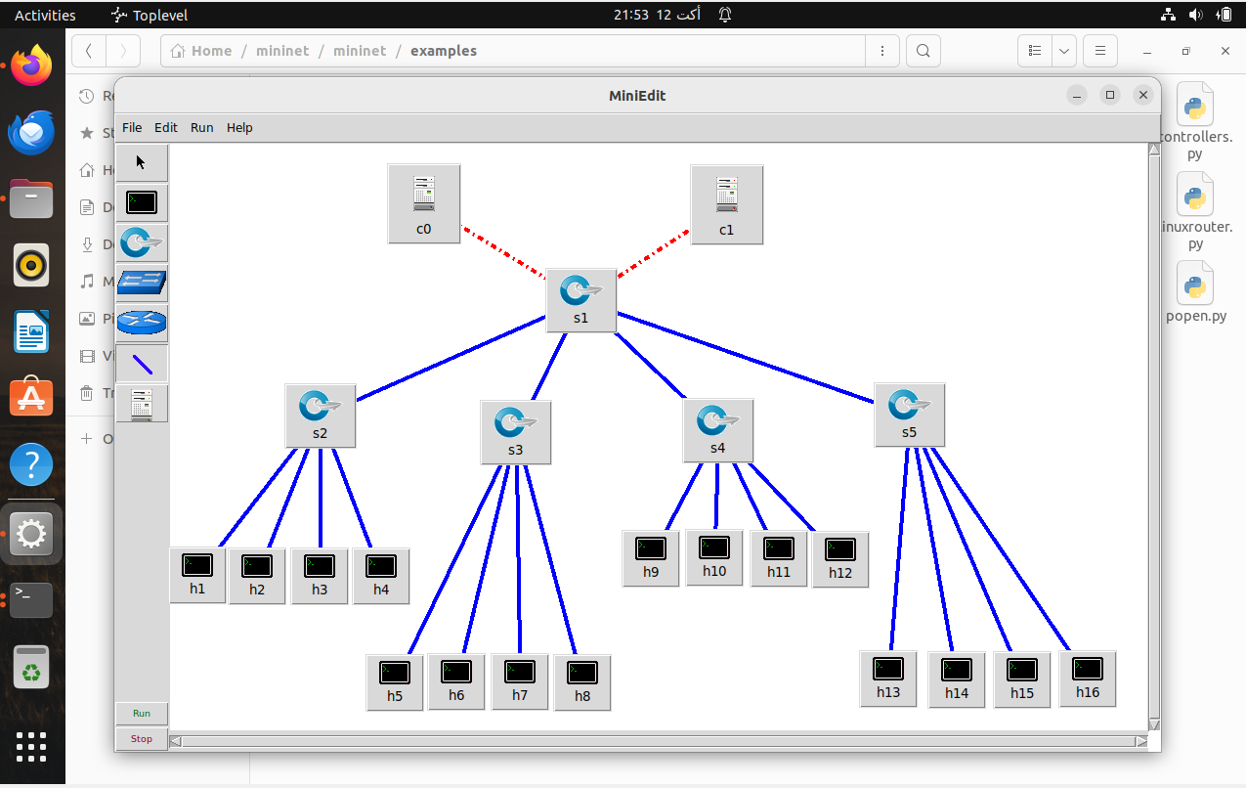

**Tree topology**

As we see here in the topo, the essential controller (c0) is connected to the core OpenFlow switch and the controller (c1) works as a mirror (data replication) to the c0 controller. If the c0 drops the c1 is still working as a (data replication).

And the core OFS is connected to four OFSs, everyone connected to four PC devices. This topo is called tree topology.

Command lines used to create this network.

**How we implement this topology:**

- open the terminal and type the following commands in this directory Home/pox to open the two controllers

*controllers 1(c0): $ ./pox.py openflow.of_01 --port=6100 forwarding.l2_pairs*

*controllers 2(c1): $ ./pox.py openflow.of_01 --port=6101 forwarding.l2_pairs*

* The **first** command opens the c0 pox controller with OpenFlow version one protocol running on it at the port "6100" and listening to the forwarding layer of the network and captures any change on it.
* The **second** command does the same job but, in the port, "6101" and the c1 pox controller here work as a mirror of c0. We got these commands from [6]

So now the controllers are up and wait for the topo to be created:

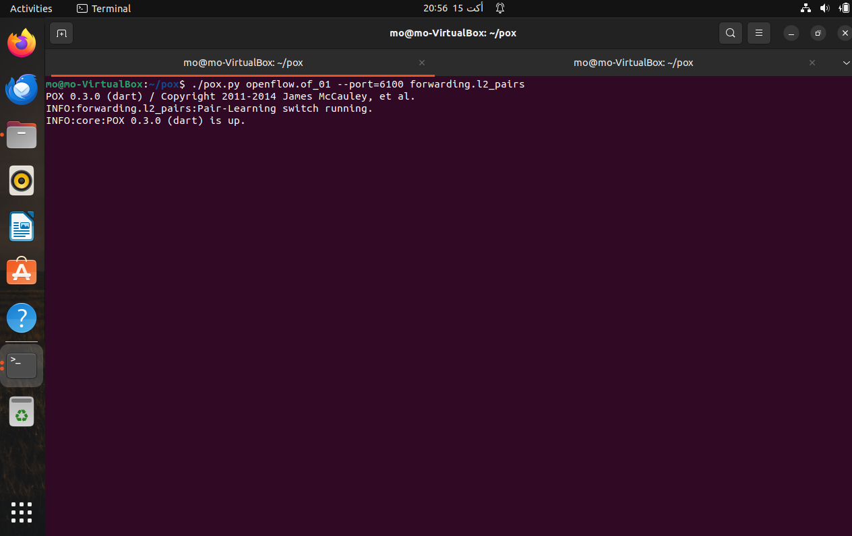

C0 is up.

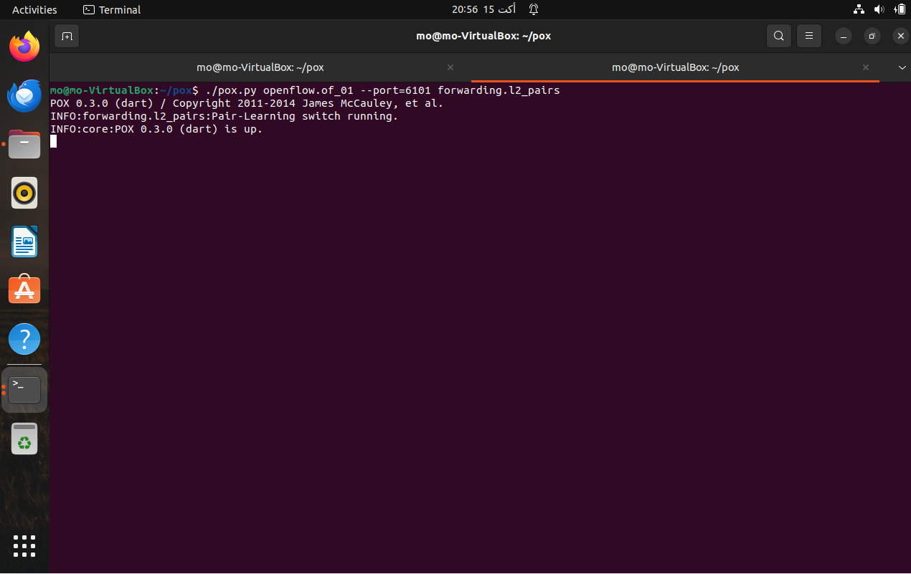

C1 is up.

Now we start to create our topo by opening a new terminal window and type the following command:

*$ sudo mn --switch ovsk --topo tree,depth=2,fanout=4 --controller remote,port=6100 --controller remote,port=6101*

* The sudo: gives the mininet a root permission to create the topo.
* --switch ovsk : This part specifies the type of switch to be used in the Mininet network. In this case, **ovsk** refers to Open vSwitch, which is a software-based switch used in virtualized environments for network virtualization, "ovsk" stands for Open vSwitch Kernel Mode .
* --topo tree, depth=2, fanout=4 : the topo type is tree and having a depth of two and fanout of four, that's means it has a core switch(s1) connected to four switches (s2,s3,s4,s5) ,each one connected to four pc devices.
* --controller remote, port=6100 : this tells the Mininet that there is a connected remote pox controller working on port "6100"
* --controller remote, port=6101 : this tells the Mininet that there is a connected remote pox controller working on port "6101"

After running the mn command the topo created successfully as follows:

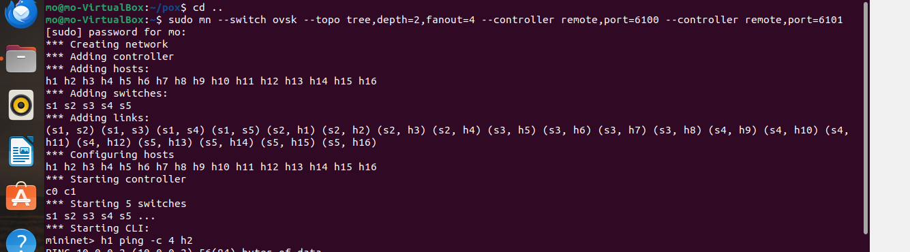

Also, the two controllers work and starting monitoring as follows:

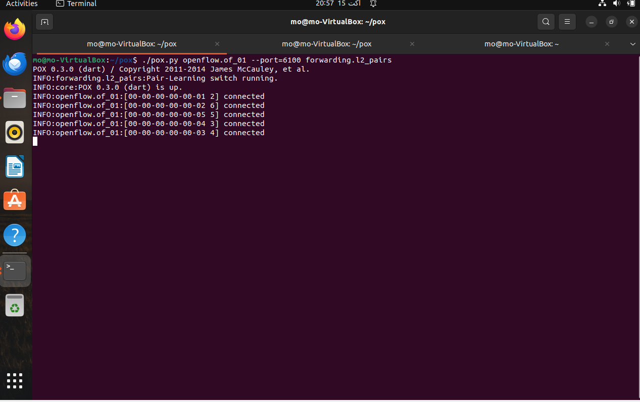

C0 connected.

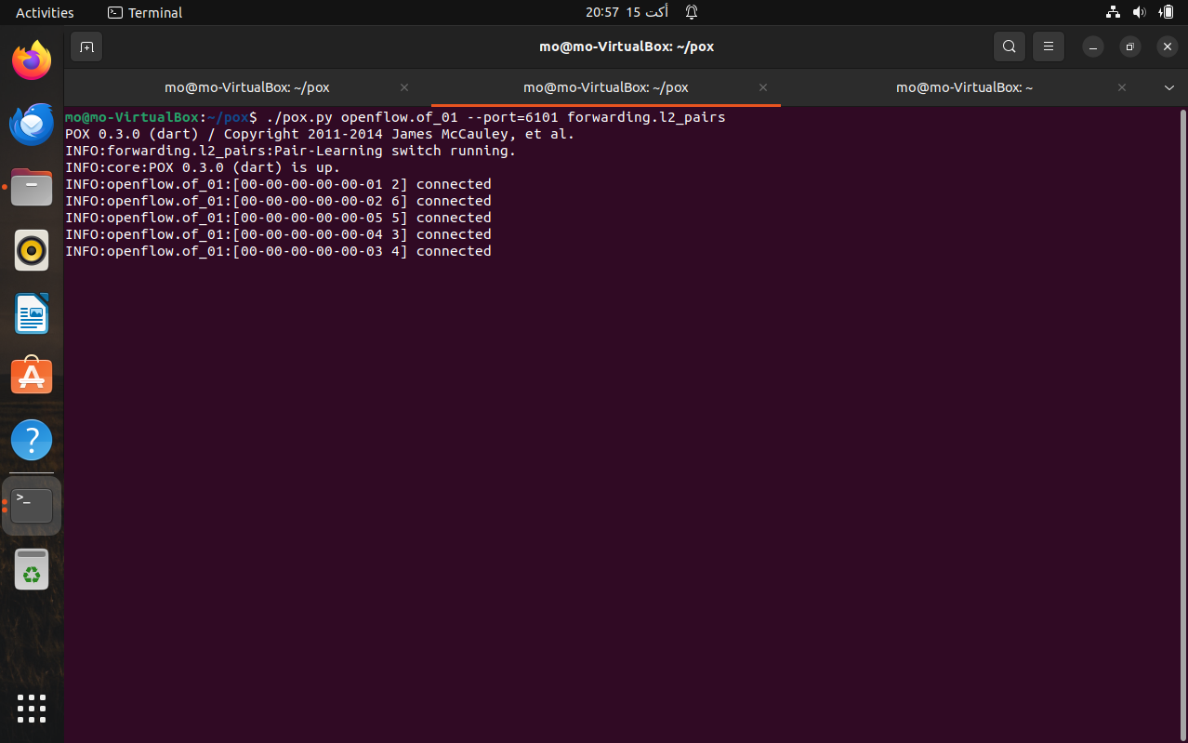

C1 connected.

Now after the topo and the two controllers are working let's check some commands.[7]

First let’s do a ping from h1 to h2 (send 4 packets)

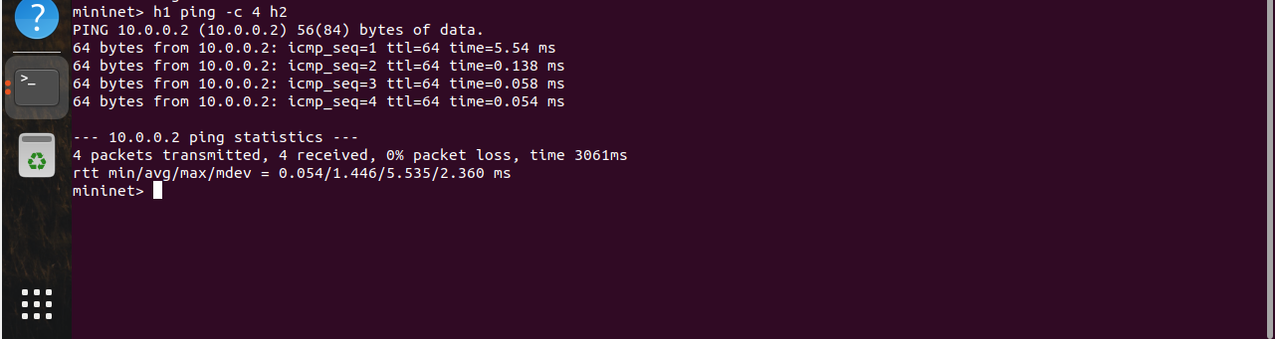

As we see here all four packets received

let’s ping on all devices.

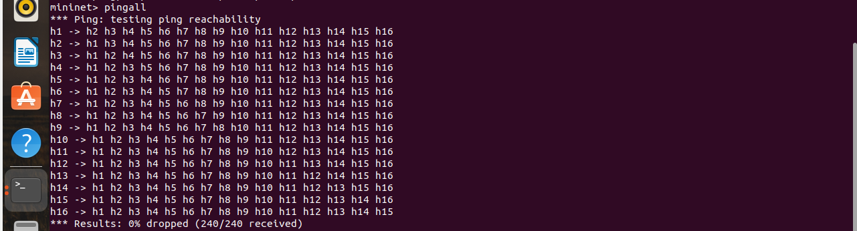

All the devices are reached to others.

Flow rules is important also to take it as a concern: -

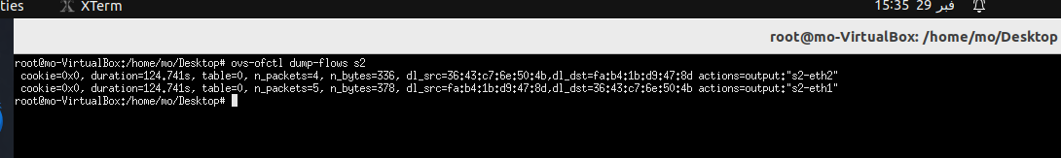

S2 flow rules after h1 ping on h2

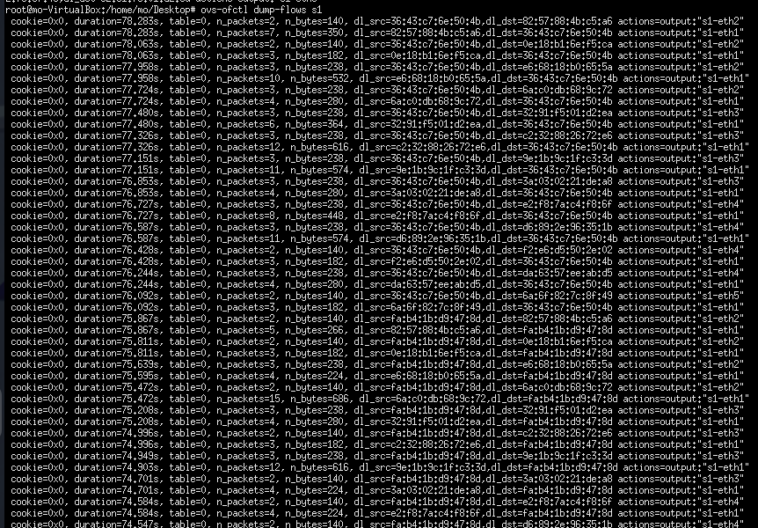

S1 flow rules after pingall and there are more flow rules.

let's check the nodes:



let's see all links:

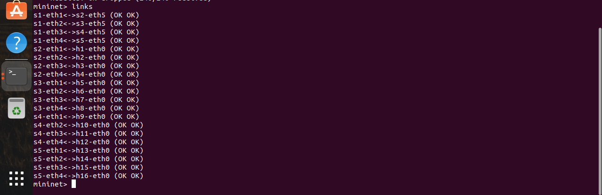

All links are connected successfully.

Let's check the bandwidth of the network (speed test):



As shownthe difference between the download speed and upload speed

**Chapter.4 Server/Client Communication**

**4.1 Overview**

To make sure of the performance of the SDN network we should do some tests to our network by running any service in the network like **FTP (file transfer protocol)**

The File Transfer Protocol (FTP) is a standard communication protocol used for the transfer of computer files from a **server to a client** on a computer network. FTP is built on a client and server architecture using separate control and data connections between the client and the server of the ftp protocol configured,

and needs an authentication between client and server by a plain text username and password which will be set in the server.

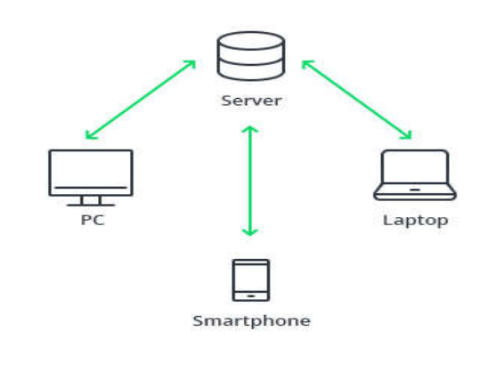

fig.6 server/client communication [6]

**4.2. the Implementation.**

1- first step at all is the installation of the ftp server (Wing FTP Server Admin) on the windows machine [8]:

2- creation of the ftp server.: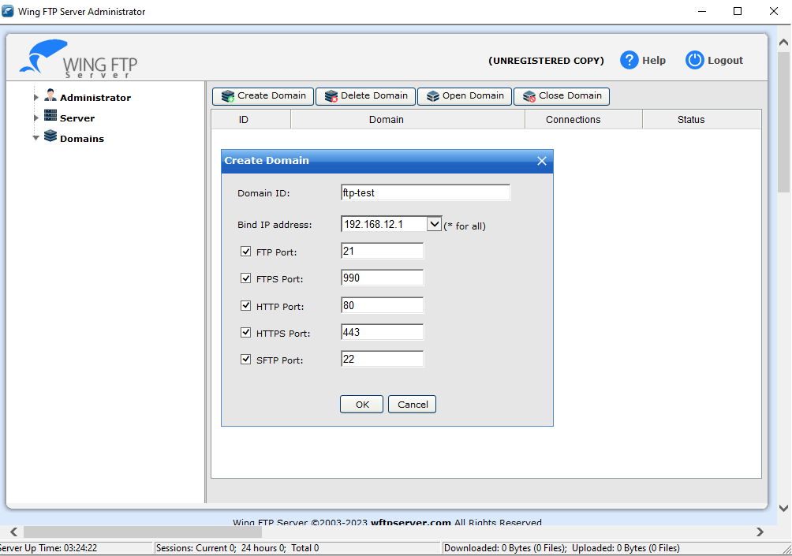

Give it the domain name and the IP of the server and check the service ports and press ok.

3- Now add a user by adding the name, password(credentials), and the directory:

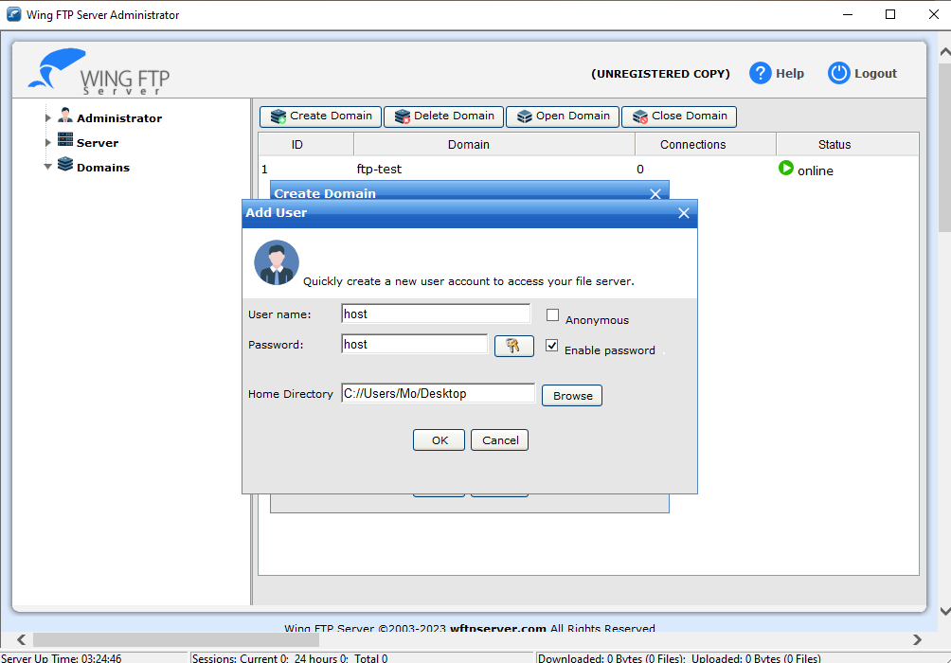

We have to change this directory after attaching some files.

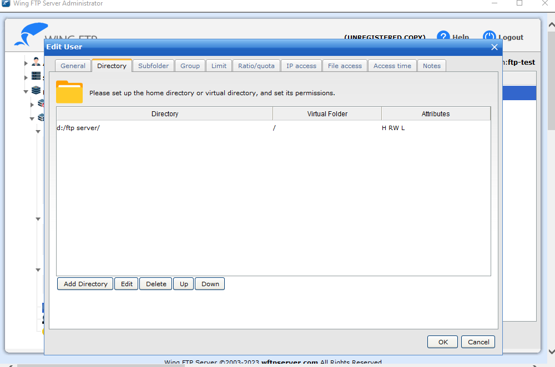

4- give the privileges of the user and press ok:

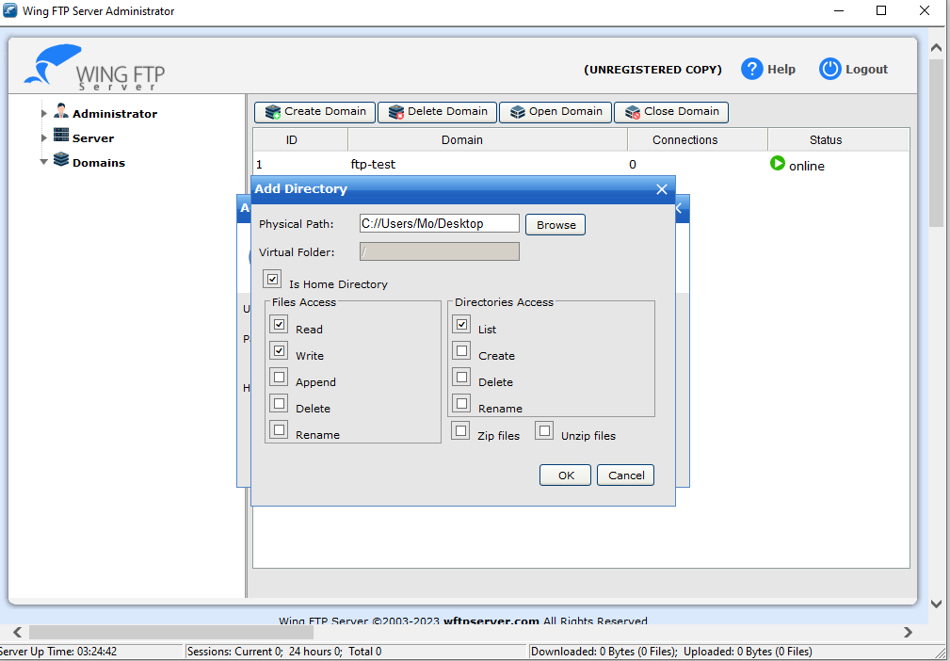

Now we created the user and the domain.

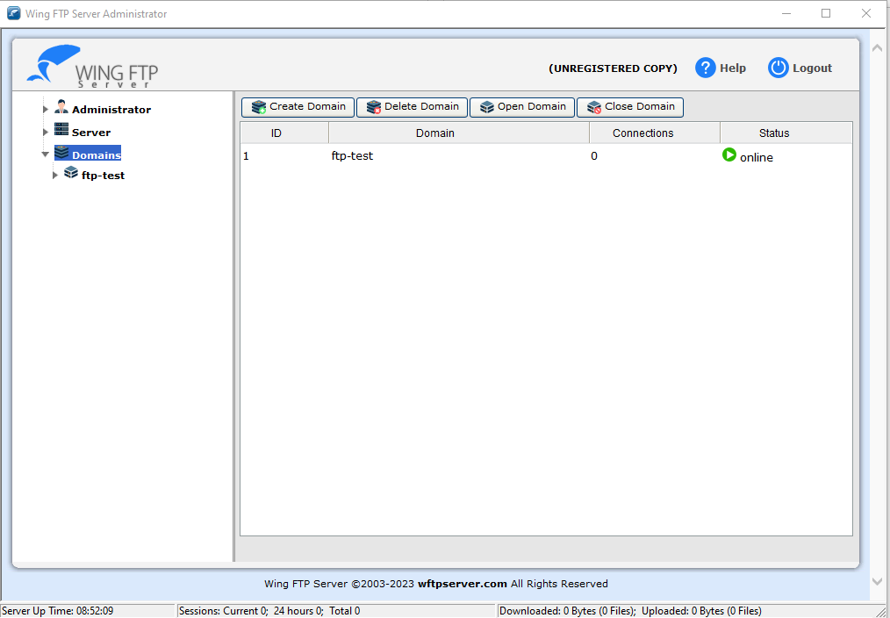

ftp-test domain is online.

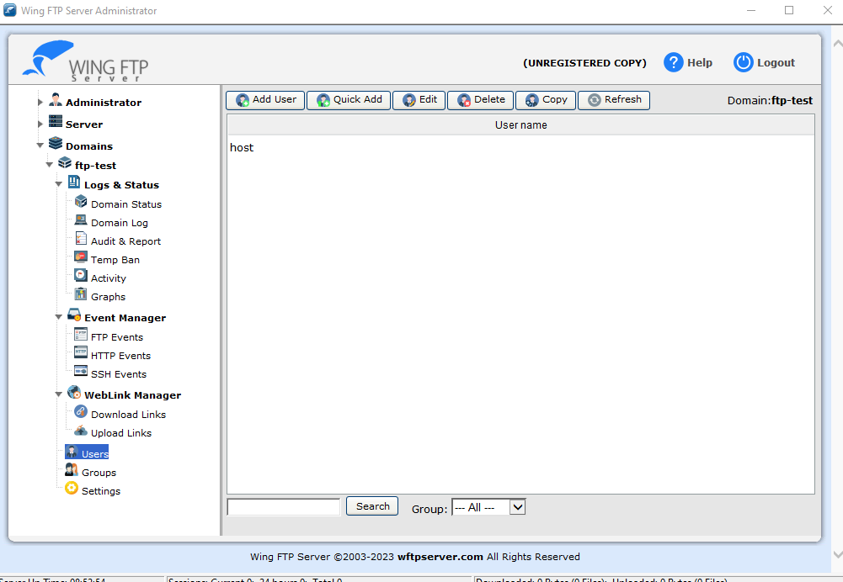

The added user.

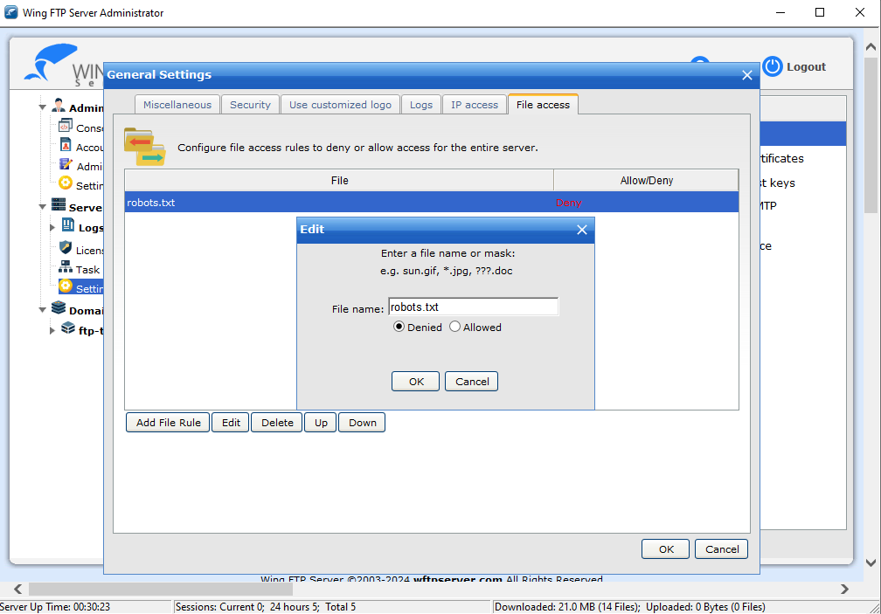

File access.

5- now we open the ubuntu machine to run the network and test our ftp server. but we faced a problem that the Mininet network is private so it cannot see the ftp server or even ping on google so it cannot reach the outside network (WWN).

So, to solve this problem we must run the **Nat protocol** in the network to connect it to the eth0 (NIC) [9]:

so, it can be done in the command that runs the topo by adding the NAT argument as follows: -

*$ sudo mn --switch ovsk* ***--nat*** *--topo tree,depth=2,fanout=4 --controller remote,port=6100 --controller remote,port=6101*

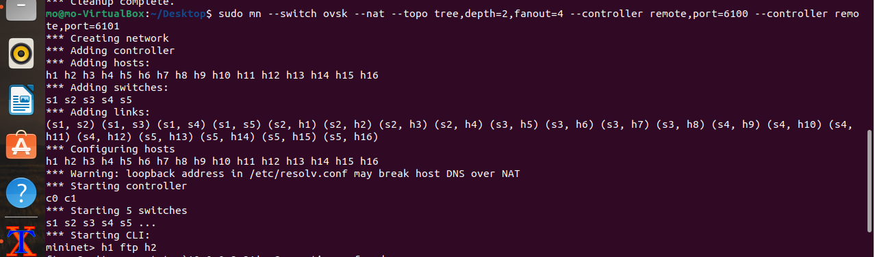

6-before creating the topo open the two pox controllers:



The 1st controller



The 2nd controller

7-Now to check that our network is connected to the WWN, ping on google's DNS:

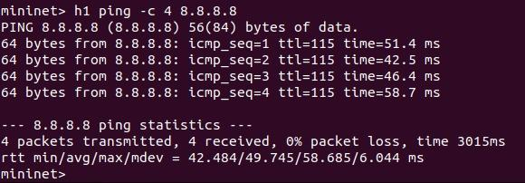

So, it works ^_^

8-we now go to check the ftp server. We tried to run the service in the Mininet cli but it doesn't work efficiently:

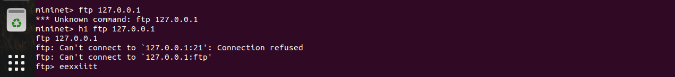

So, we tried another way by xterm tool (cli) of the hosts. We choose host1 to download the file.

9- On the CLI of h1 do the following:

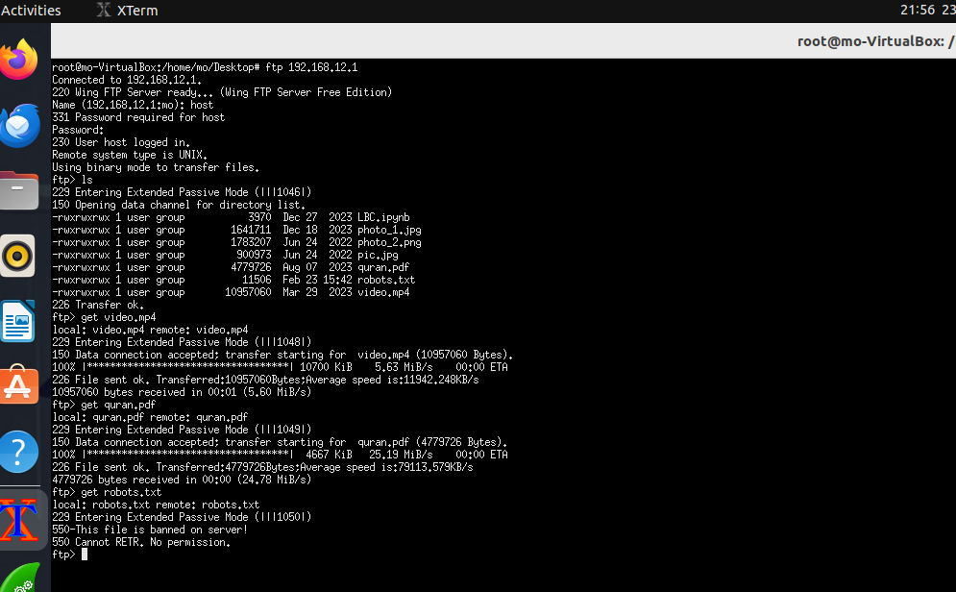



1- Connect to the server by typing ( ftp 192.168.12.1 ) to request connection with the ip address.

2- Entering the username of the user that we created.

3- Enter the password also.

4- Now we connected successfully to the server and typed *ls* to see the files stored in the server.

5- The available files stored on the server.

6- Downloading the video by *get* command from the server on the host.

7- Downloading another pdf file.

8- Trying to download the banned file.

9-No permission as expected.

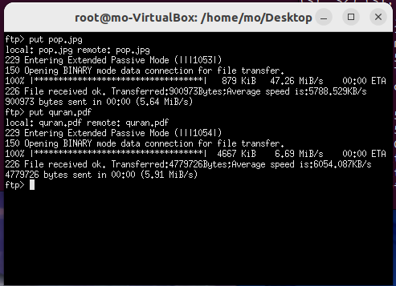



10- uploading a photo to the server.

11- uploading another file to the server.

10-Capturing the packets using Wireshark:

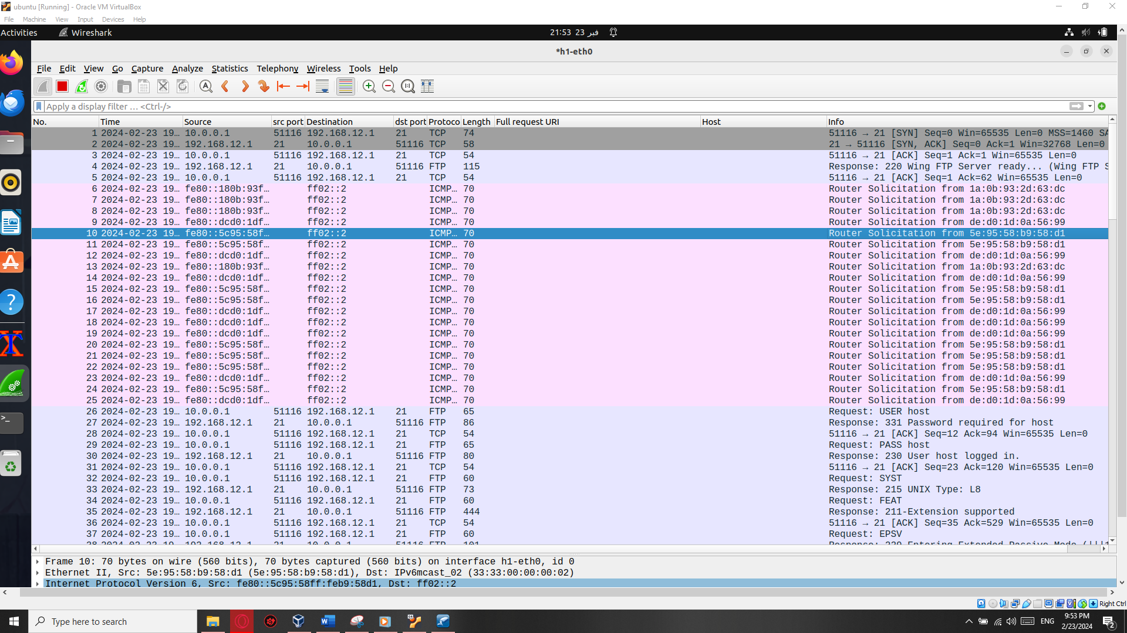

As we see TCP uses a three-way handshake to establish a reliable connection and Authentication between the host and the server. After that the process of transferring files starts using ftp protocol.

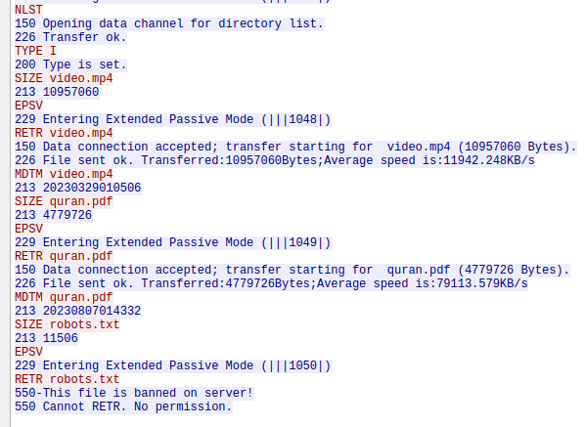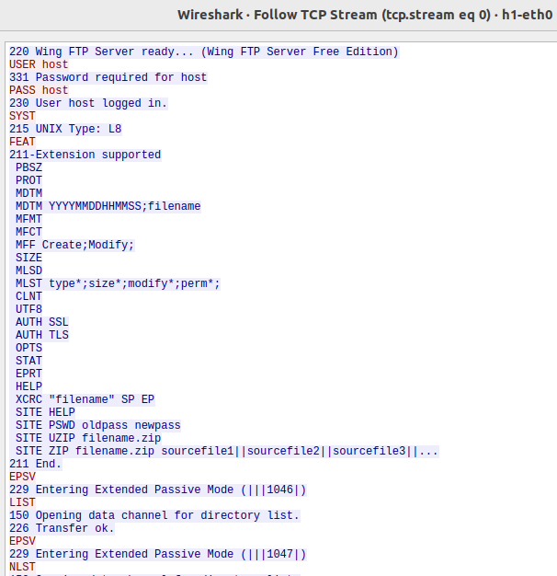11- If we follow the tcp stream we’ll see all the data (traffic) as a plaintext: because ftp protocol is not secure.

12- Back to the server and see the logs status:

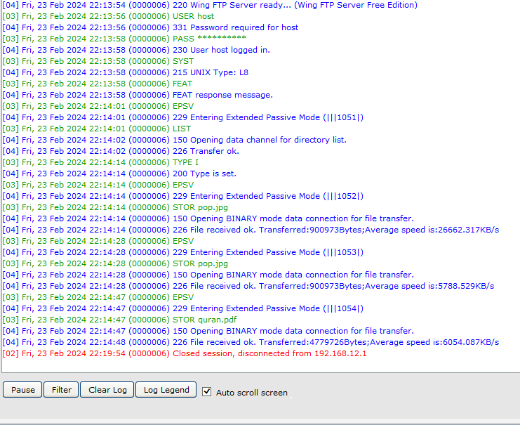

Domain log saved in the server and all sessions.

Ex: the last uploaded files to the server.

13- Audit & Reports can also be seen:

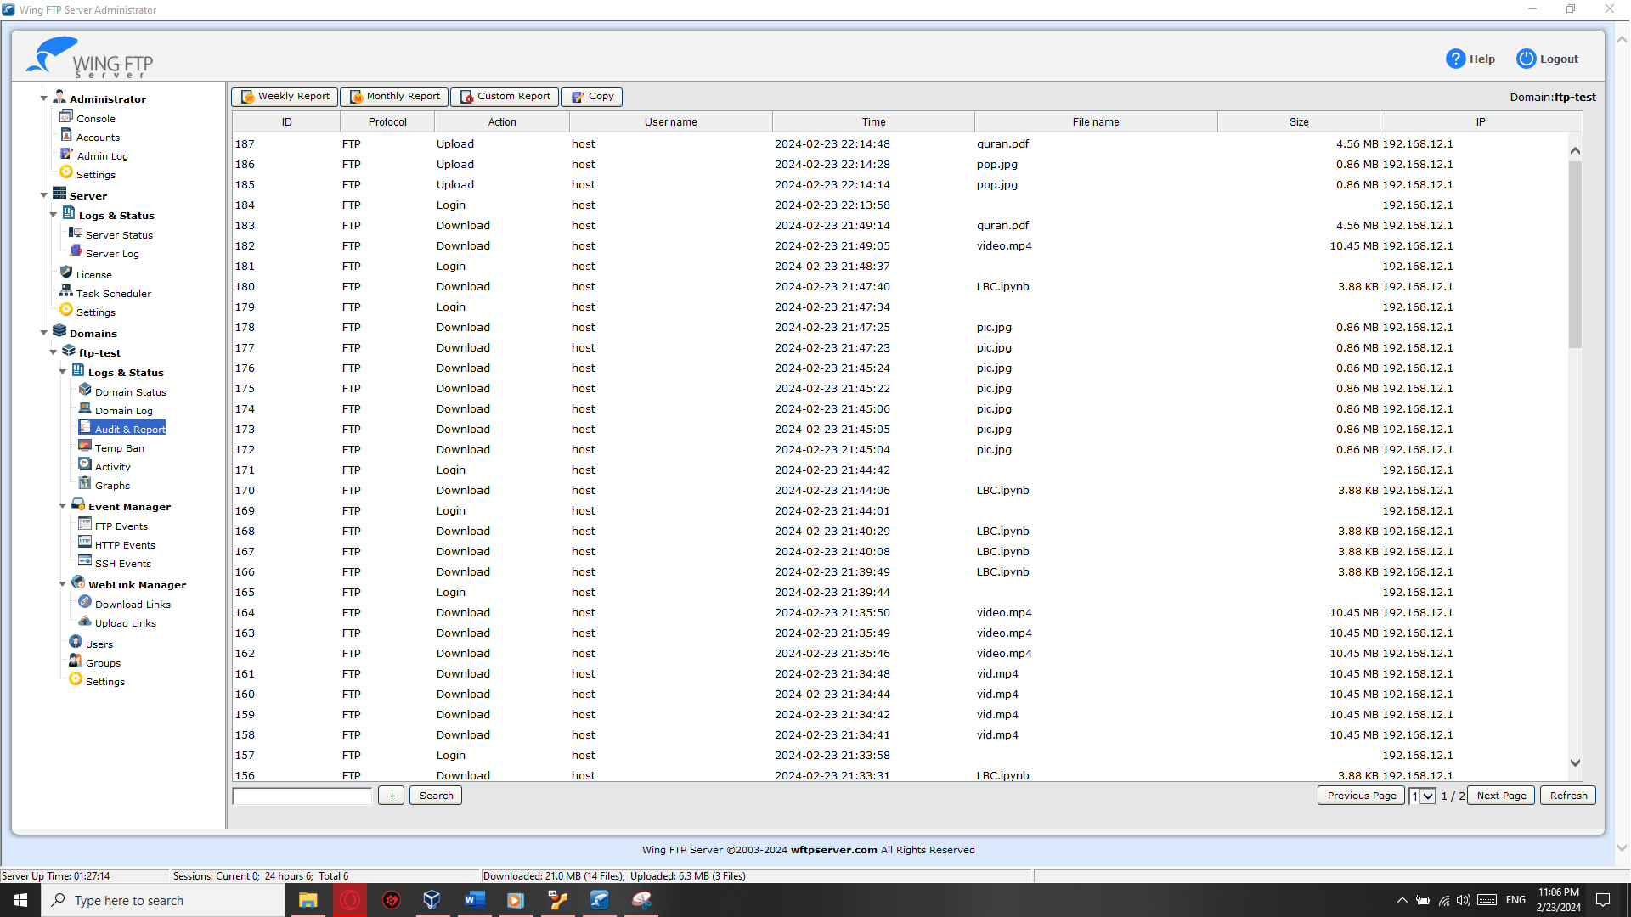

Includes (ID,protocol,Action,username,time,file name,size and server ip address)

14- Graphs:

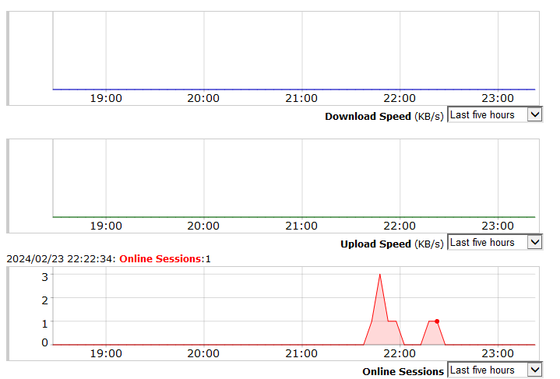

Graphs show the number of online sessions, the download and upload speed.

**Chapter.5 Point To Point Communication (P2P).**

Point-to-Point Protocol (P2P) is a client-to-client data link protocol used to establish a direct connection between two nodes, unlike FTP which is a client to server protocol.

P2P is a widely used protocol that provides a reliable, efficient, and flexible means of establishing point-to-point connections between devices. It is supported by most operating systems and networking equipment and is used in a variety of applications, including internet access, remote access, and VPNs.

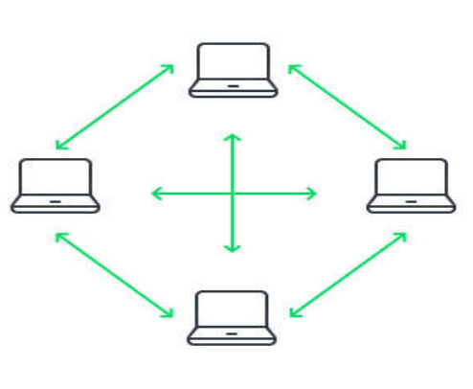

Fig.7 p2p communication [7]

**5.1 what is netcat tool**

Netcat, also known as "nc" is a powerful and versatile networking utility tool used for reading from and writing to network connections. It provides a simple and straightforward way to create TCP/IP. connections, listen for incoming connections, transfer data, and perform various network-related tasks Netcat can act as both a client and a server, making it useful for a wide range of tasks, such as:

1)Port scanning: Netcat can be used to scan for open ports on a remote host by attempting to establish a connection to different ports and analyzing the response

**2)File transfer: It can facilitate the transfer of files between hosts by establishing a connection and sending or receiving data.**

3)Port forwarding: Netcat can forward network traffic between ports or hosts, allowing for advanced network configurations and tunneling.

4)Network testing: It is commonly used for testing network services, checking connectivity, and troubleshooting network-related issues.

5)Remote administration: Netcat can be utilized to execute commands remotely on a remote server or host by establishing a connection and sending commands.

Netcat is highly flexible and can be used in various scenarios due to its ability to handle raw network connections. Its simplicity, combined with its wide range of uses, makes it a popular tool among networks. administrators, security professionals, and enthusiast

**5.2 nc installation**

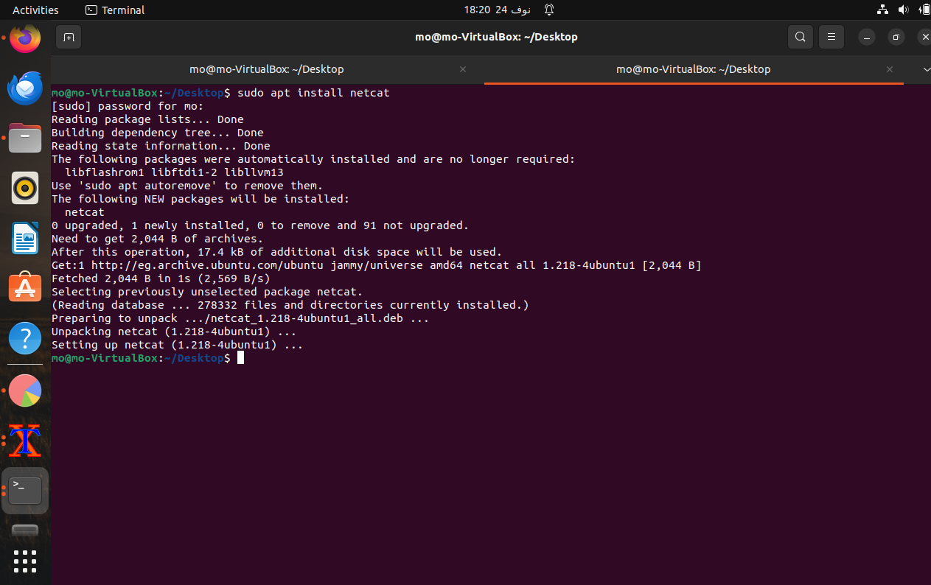

**5.3 How to use nc tool**

1-Open the cli of h1 and h16 by xterm and run the next commands:

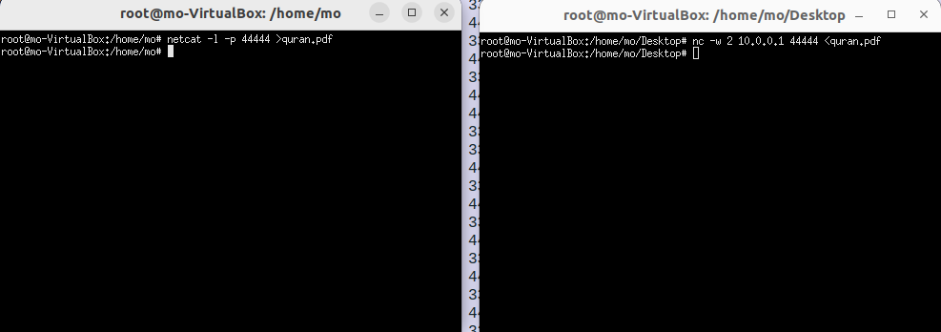

h1 is listening for an incoming connection h16 sends the file

2-Capturing the packets using Wireshark.

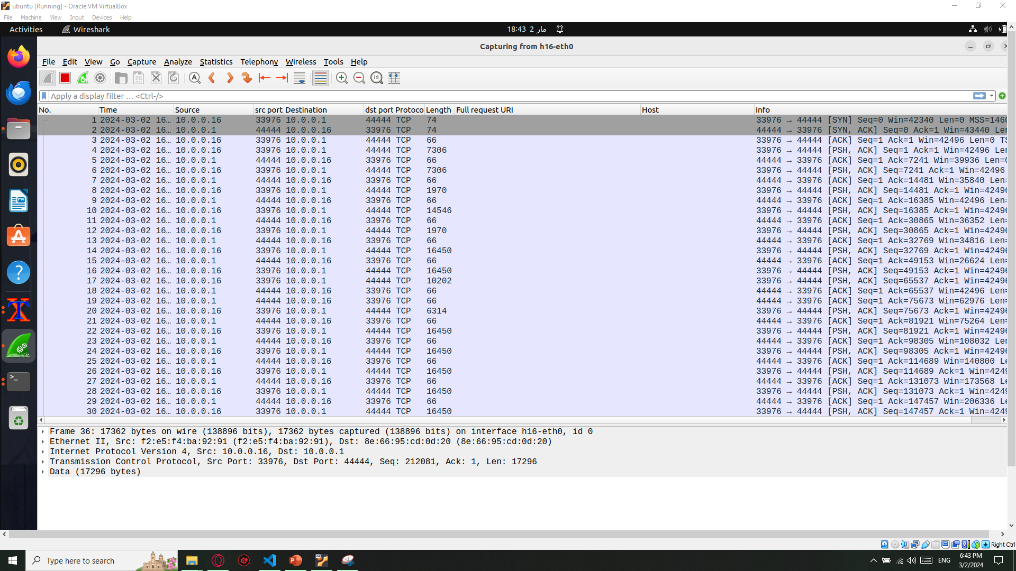

The start of the connection

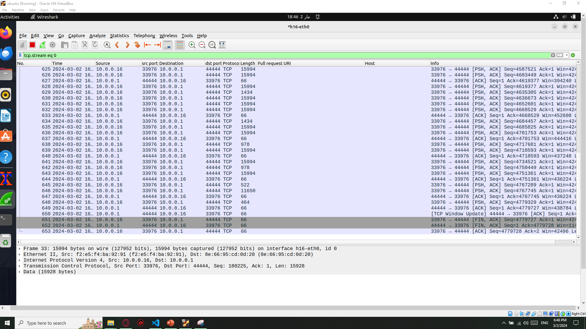

The end of the connection and file transferred successfully.

**Chapter.6 Web service**

In an SDN (Software-Defined Networking) network created using Mininet and a controller like Ryu or POX, it is possible to make a host function as an HTTP server. This means that the host can serve web content and respond to HTTP requests from other hosts in the network. By leveraging the capabilities of SDN, we can dynamically configure the network to direct traffic towards the HTTP server host.

**6.1.Benefits:**

1. Network Flexibility: SDN enables the dynamic configuration of network flows, allowing us to easily redirect HTTP traffic towards the designated HTTP server host. This flexibility allows for efficient utilization of network resources.

2. Centralized Control: With an SDN controller like Ryu or POX, we can centrally manage and control the network, including the HTTP server configuration. This centralized control simplifies the management and deployment of the HTTP server compared to traditional networks.

3. Traffic Isolation: By isolating the HTTP server host from other hosts in the network, we can ensure that the server's resources are dedicated to serving HTTP requests. SDN allows us to define specific flows and rules to direct traffic only towards the HTTP server, ensuring efficient resource allocation.

4. Scalability: SDN networks are highly scalable, allowing for the easy addition or removal of hosts and the configuration of HTTP servers. This scalability ensures that the network can adapt to changing requirements and handle increased traffic loads.

5. Traffic Monitoring and Analytics: SDN controllers provide advanced monitoring and analytics capabilities. By monitoring the traffic directed towards the HTTP server host, we can gain insights into the usage patterns, performance metrics, and potential bottlenecks. This information can be used for network optimization and capacity planning.

6. Simplified Network Management: SDN networks abstract the complexity of network management using a centralized controller. This simplification allows for easier configuration and administration of the HTTP server host compared to traditional approaches.

By leveraging Mininet, SDN controllers, and configuring a host as an HTTP server, we can harness the benefits of SDN to create a scalable, flexible, and efficient network that serves web content.

**6.2.The implementation:**

1. Start with creating the topo by this command *$ sudo mn --switch ovsk --nat --topo tree,depth=2,fanout=4 --controller remote,port=6100 --controller remote,port=6101 --ipbase=10.0.1.0/8 .*
2. Before creating the topo initiate the two-pox controller by these commands

*controllers 1(c0): $ ./pox.py openflow.of_01 --port=6100forwarding.l2_pairs*

*controllers 2(c1): $ ./pox.py openflow.of_01 --port=6101 forwarding.l2_pairs*

1. Open the CLI of h1 by this command $h1 xterm
2. Make h1 the http server by this command $python -m http.server 8000

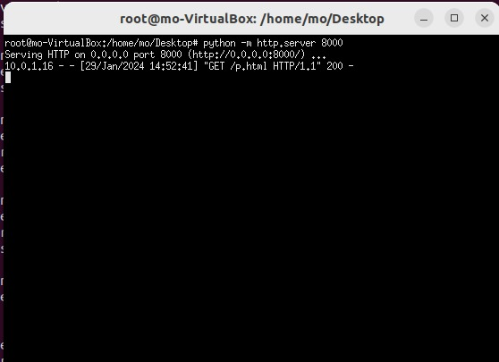

This command starts an HTTP server on port 8000.

1. we have a photo file on my Desktop with html format (p.html).
2. In another terminal, open a terminal (CLI) for the host where we want to retrieve the file (e.g., h16).And type this command *$wget* [*http://10.0.1.16:8000/p.html*](http://10.0.1.16:8000/p.html)

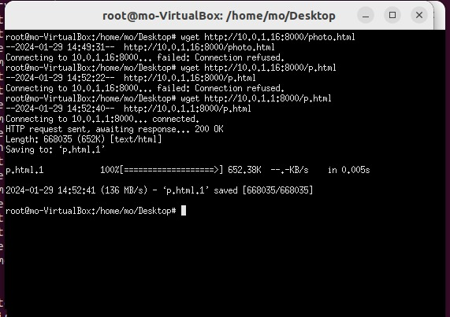

The command `wget http://10.0.1.1:8000/p.html` is used to download a file named `p.html` from a web server running at the IP address `10.0.1.1` on port `8000`.

Here's a breakdown of the command:

1. `wget`: It is a command-line utility used for retrieving files from the web.
2. `http://10.0.1.1:8000/p.html`: This is the URL of the file you want to download. It consists of the following components:
3. `http://`: It specifies the protocol used for communication, in this case, Hypertext Transfer Protocol (HTTP).
4. `10.0.1.1`: It represents the IP address of the web server hosting the file.
5. `:8000`: It denotes the port number on which the web server is listening. In this case, it is port `8000`.
6. `/p.html`: It is the path to the specific file you want to download from the web server. In this case, it is `p.html`.

When you execute this command, `wget` will send an HTTP request to the specified URL. If the web server is running and accessible at `10.0.1.1:8000`, it will respond with the content of the `p.html` file. `wget` will then save the file in the current directory on your local machine where you executed the command.

1. The capture with Wireshark

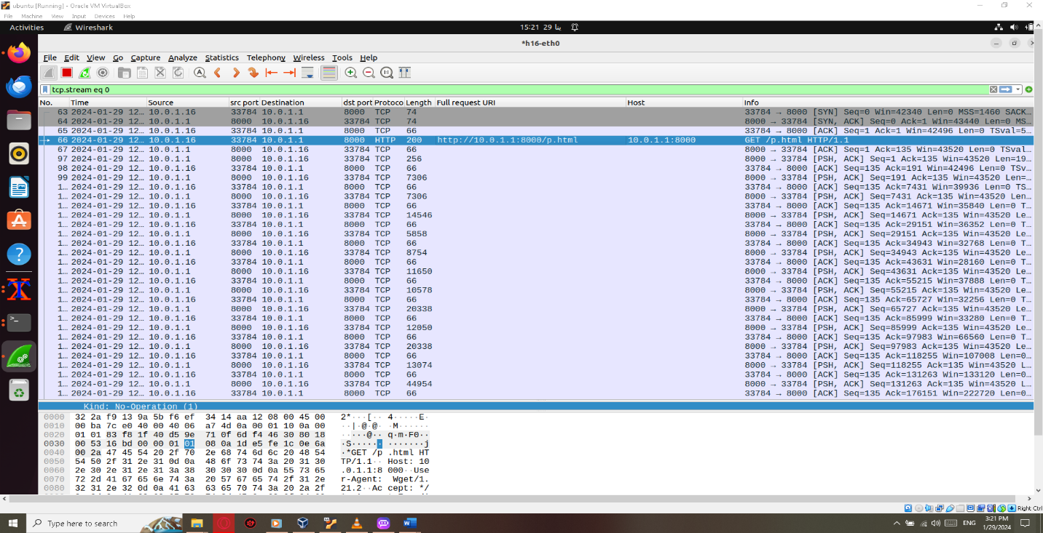

The request of the file.

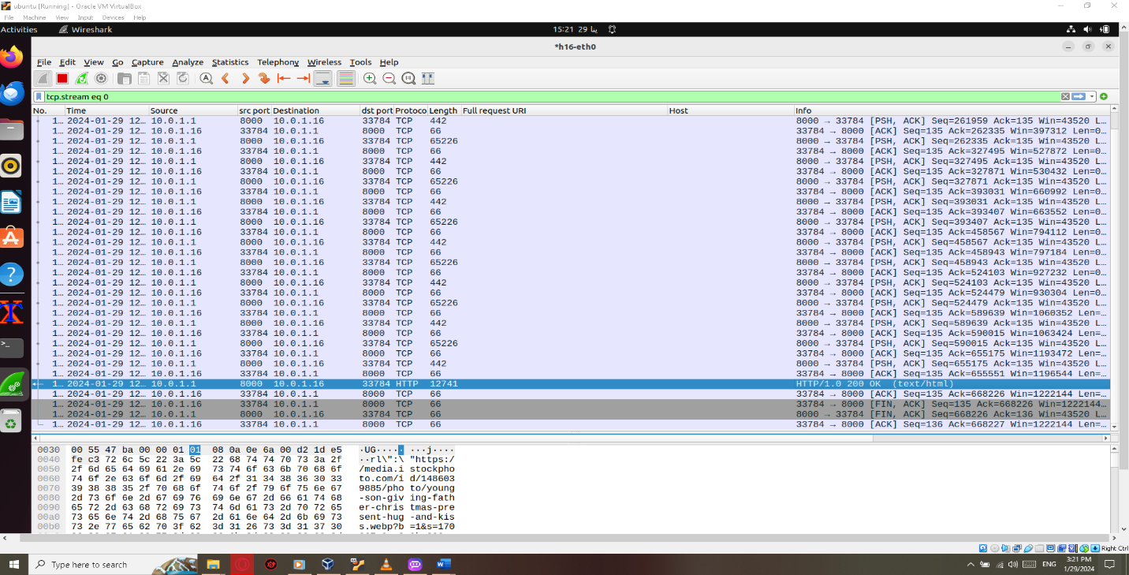

the file received successfully.

**Chapter.7 Traceroute**

Traceroute is a network diagnostic tool that traces the route taken by packets sent from your computer to a destination IP address or domain name. It is commonly used to identify the network path and measure transit delays of packets across an IP network, such as the internet. The traceroute command is available on most operating systems, including Windows, macOS, and Linux, and it is typically used from the command line interface (CLI).

**6.1 installation of traceroute tool.**



The tool installed successfully.

**6.2 traceroute tool usage.**

By typing the following command:  
*$traceroute (dest IP)*

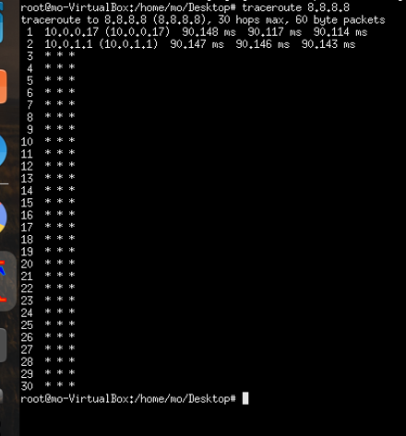

Note: the error in using the tool, we don’t see the next hop, we only see ******

The problem discussed above was due to the network adapter settings. it was configured as a NAT network adapter which is used when internet services needed, and it’s more secure because it doesn’t accept external connections from outside the private network, and here’s the problem the traceroute is done using packets arises from the source to the hops then return to the source and the source drops these packets as it’s configured as a NAT network.

So, the solution of the problem will be to change the network adapter setting from NAT to Bridged or add another network adapter configured as bridged as it accepts external connections from outside private network and takes a public ip not like the NAT configuration which takes private ip.

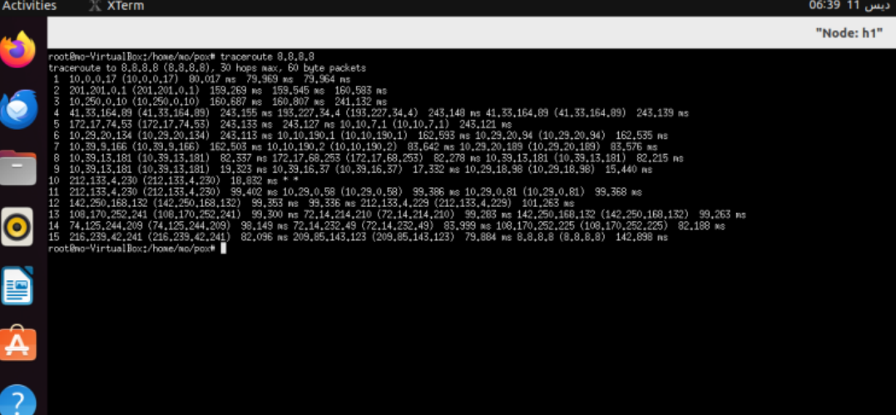

After configuring the bridged network adapter, the problem solved, and the tool works accurately.

Note:

In a typical traceroute output, you will often see three different time intervals (round-trip times or RTTs) reported for each hop along the network path. These time intervals represent different measurements of the round-trip time taken by packets to reach the respective router and receive a response. Here's why you see these three values:

**1- Minimum RTT:** This is the shortest round-trip time recorded during the traceroute process. It represents the fastest time it took for a packet to travel from your computer to the router and back.

**2-Average RTT:** This is the average round-trip time calculated from all the packets sent to the router. It provides a general idea of the typical round-trip time experienced during the traceroute process.

**3- Maximum RTT:** This is the longest round-trip time recorded during the traceroute process. It represents the slowest time it took for a packet to travel from your computer to the router and back.

The reason you see three values is to give you a sense of the range of round-trip times experienced at each hop. This can be useful in understanding the variability and potential bottlenecks in the network path. It's important to note that these RTT values can be influenced by various factors, including network congestion, routing policies, and the load on the routers. As a result, the RTT values you see in a traceroute output may not always accurately reflect the actual performance of the network.

**Chapter 7 Route validation**

In Software Defined Networking (SDN), route validation plays a pivotal role in ensuring the efficient and reliable forwarding of data packets within the network infrastructure. Route validation involves the verification and confirmation of the paths that network traffic takes from its source to its destination. This process is essential for maintaining network performance, security, and stability.

At its core, route validation in SDN networks revolves around confirming that the network devices, such as switches and routers, are forwarding traffic along the intended paths as per the defined routing policies. By validating routes, network administrators can ensure that data packets are delivered accurately and

efficiently, minimizing latency, congestion, and potential security risks.

Route validation encompasses various aspects, including:

**Path Integrity:** checking that the paths chosen for forwarding traffic are intact and free from any disruptions or failures that may result in packet loss or network downtime.

**Policy Compliance:** Verifying that the routing decisions align with the configured network policies and access control rules to enforce security measures and compliance requirements.

**Optimal Routing:** Confirming that traffic is being routed through the most efficient paths based on factors such as available bandwidth, latency, and network topology to optimize performance and resource utilization.

**Fault of tolerance**: Ensuring that the network has built-in redundancy and failover mechanisms to handle link failures or network outages without impacting the continuity of service.

**7.1 How we can validate route by adding more links**

First we need to add links between end switches by running the following commands

py net.addLink(s2,s3)

py net.addLink(s2,s3)

py net.addLink(s4,s5)

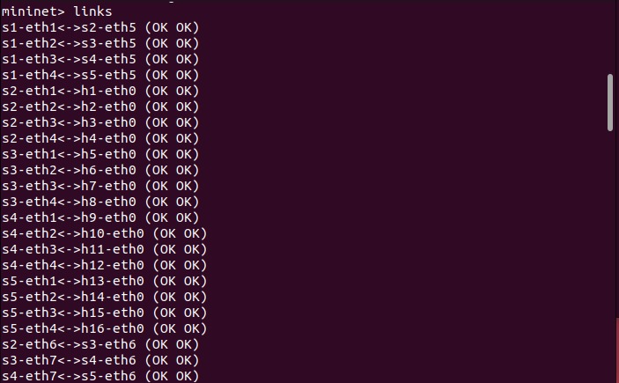

Links added successfully.

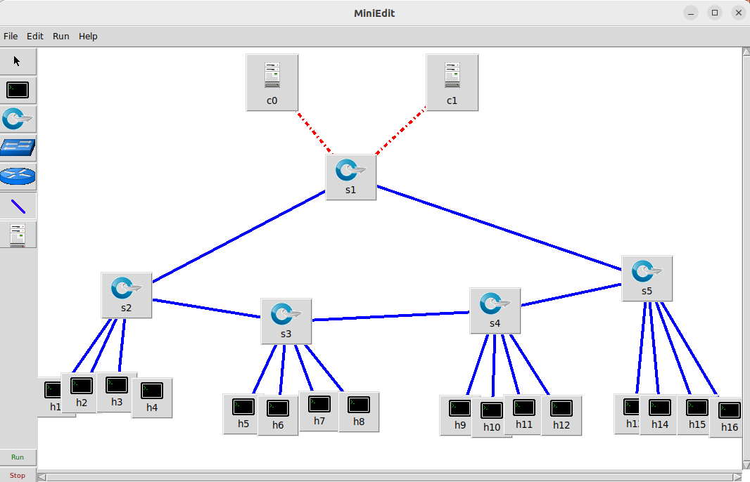

**7.2 Validate source and destinations Ends**

By pinging between 2 hosts (h1 –h5)

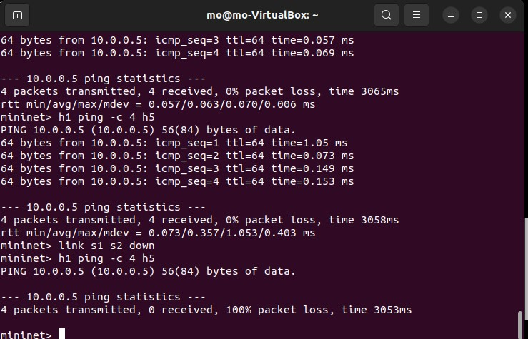

Here we need to calculate time between 2 hosts

By Running Ovs-dump command to calculate Duration and check src and destination

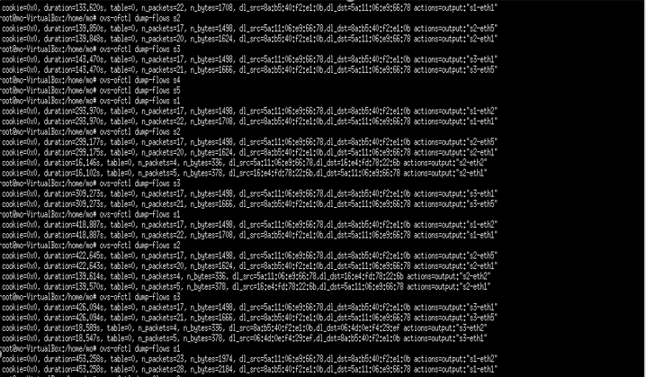

**7.3 Capturing data through Wireshark and calculating Band width.**

Bw=total data transferred (in bits)/capture duration

(Inbits)=8*(inbytes)

s2-eth1<->h1-eth0…bw=98*8*8bits/(32-29)sec

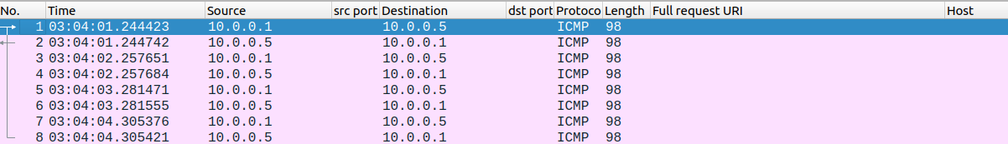

We noticed total data transferred

s1-eth1<->s2-eth5…bw=98*8*8bits/(22-19)sec

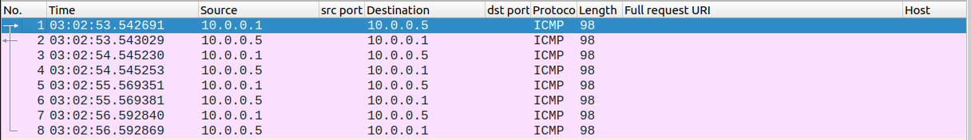

s1-eth2<->s3-eth5…bw=98*8*8bits/(27-24)sec

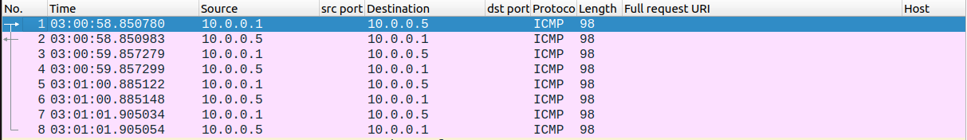

**7.4 Observations**

As observed time and length of packets didn’t change as we only have one core switch so path of the packet won’t change so we can’t validate Best route.

So our Network should be customized by add a second controller and links between switches to prove

1. Prove Route validation concept.
2. Prevent SOP (Single point of failure) Concept .

**Conclusion**

Our evaluation confirmed the basic functionality of the Software-Defined Network (SDN) through various testing methods, including diverse topologies, server/client communication establishment, point-to-point connection setup, and route validation. Integrating a web service deployment section would offer a more comprehensive picture.

To further assess the network's robustness, a Denial-of-Service (DoS) attack simulation and analysis should be incorporated. This would involve defining the attack type, simulating it, observing network behavior, and analyzing its effectiveness and the network's resilience.

This comprehensive evaluation will provide valuable insights into the SDN's strengths, weaknesses, and its ability to withstand attacks, ultimately informing decisions about its suitability for your specific needs.

**References:**

1. OpenFlow-enabled SDN and Network Functions Virtualization ONF Solution Brief February 17, 2014.
2. Software-Defined Networking a Comprehensive Survey, D. Kreutz and F. M. V. Ramos, June 15, 2014.
3. Retrieved from [Mininet · GitHub](https://github.com/mininet)
4. Retrieved from www.openvswitch.org: https://www.openvswitch.org
5. High Availability in Software-Defined Networking using Cluster Controller: A Simulation Approach, Abhimata Zuhra Pramudita
6. K. Benzekki, A. El Fergougui and A. Elbelrhiti Elalaoui, "Softwaredefined networking (SDN): a survey," Security and Communication Networks,
7. [Retrieved from mininet.org](https://mininet.org/walkthrough/): https://mininet.org/walkthrough/
8. Retrieved from wftpserver.com: <https://www.wftpserver.com>
9. Retrieved from stackoverflow.com: https://stackoverflow.com/questions/50421826/connecting-mininet-host-to-the-internet
10. H. G. Ahmed and R. Ramalakshmi, "Performance Analysis of Centralized and Distributed SDN Controllers for Load Balancing Application," 2018 2nd International Conference on Trends in Electronics and Informatics , 2018
11. Network Functions Virtualisation (NFV): Network Operator Perspectives on Industry Progress, ETSI, October 2013.
12. Open Networking Foundation (ONF), ‘‘Conformance test specification for OpenFlow switch specification,’’ Tech. Rep., Jun. 2013

**Figures:**

1. <https://bradhedlund.com/2011/04/21/data-center-scale-openflow-sdn/>
2. <https://www.semanticscholar.org/paper/A-Northbound-API-for-QoS-Management-in-Real-Time-on-Humernbrum-Glinka/1726f794e8c760239df448aefbd3272c063fc31f>
3. <https://www.google.com/url?sa=i&url=https%3A%2F%2Fmedium.com%2F%40induwaraudanaranaweera%2Fsoftware-defined-networking-sdn-31d814894919%3FresponsesOpen%3Dtrue%26sortBy%3DREVERSE_CHRON&psig=AOvVaw1LZMZJTqudl4LiKCiu5du2&ust=1709252670662000&source=images&cd=vfe&opi=89978449&ved=0CBQQjhxqFwoTCLCRmcSkz4QDFQAAAAAdAAAAABAE>
4. <https://www.ictshore.com/free-ccna-course/sdn-introduction-network-programmability/>
5. <https://www.google.com/url?sa=i&url=https%3A%2F%2Fwww.defne-rotary.org%2Fsdn-vs-traditional-network&psig=AOvVaw1GuFXVLCr75Zb7hBp1mHAl&ust=1709248653773000&source=images&cd=vfe&opi=89978449&ved=0CBQQjhxqFwoTCNDV0syVz4QDFQAAAAAdAAAAABAJ>
6. <https://www.researchgate.net/publication/352213267_REVIEW_OF_BLOCKCHAIN_ARCHITECTURE_A_SURVEY/figures?lo=1&utm_source=google&utm_medium=organic>
7. <https://www.researchgate.net/publication/352213267_REVIEW_OF_BLOCKCHAIN_ARCHITECTURE_A_SURVEY/figures?lo=1&utm_source=google&utm_medium=organic>